Ganfeng Lithium

Equity Research Report


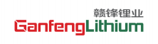

Ganfeng Lithium Group Co., Ltd.
Hong Kong Stock Exchange HKEX: 01772
Current Price: HKD 37.780
Target Price: HKD 25.500
Downside: 32%
Industry:New Energy Materials一Lithium & Battery Value Chain As of 2025/09/05
Recommandation
SELL
Executive Summary:Powering the Energy Revolution, but confronting new realities
We initiate coverage on Ganfeng Lithium (1772.HK) with a SELL recommendation and a 12-month target price of HKD 25.5, representing a 32% downside from the current market price. Our

Figure1: Summary
Source：Capital IQ ，Team Analysis
valuation is primarily based on a DCF model (WACC 5.1%, g = 2.0%) cross-checked with peer multiples. Despite being a global leader in lithium with an integrated business model spanning mining, processing, and battery recycling, Ganfeng faces short-term earnings pressure and

RECOMMENDATION | SELL
Valuation Date | 05.09.2025
Target Price HKD | 25.52
Current Price HKD | 37.78
Downside % | -32.5
Shares Outstanding | 20.04B
52 Week High HKD | 28.30
52 Week Low HKD | 14.92

financial headwinds that outweigh its long-term potential.
GANFENG IS A GLOBAL LEADER – BUT IN A DIFFICULT CYCLE
Ganfeng holds one of the most diversified lithium portfolios worldwide, covering salt lake brine, spodumene, and lithium clay projects across China, Argentina, Mali, and Mexico. Its vertical
integration ensures security of supply, downstream reach into battery production, and strategic partnerships with EV giants like Tesla, LG Chem, and BMW. However, global lithium oversupply has driven carbonate prices down from RMB 600,000/ton in 2022 to below RMB 100,000/ton in 2024, putting heavy pressure on margins.
INVESTMENT PILLAR #1: Integration and Resource Diversification Provide Strategic Advantage
The company’s ecosystem spans the entire value chain, from upstream mining to downstream recycling. Equity output is expected to reach 100,000 tons in 2025, raising its self-sufficiency
ratio to ~60%. This integration offers cost flexibility and stability across cycles. Yet, in the current downcycle, volume growth cannot offset pricing pressure.

Figure2: Detailed performance data
Source: Team Analysis,Stooq.pl
INVESTMENT PILLAR #2: Financial Deterioration Raises Red Flags
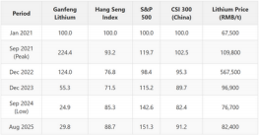
Revenue plunged 43% YoY in 2024 to RMB 18.7bn, with a net loss of RMB 2.1bn. Gross margin
collapsed from 49% in 2022 to 11% in 2024. Total liabilities surged to RMB 53.2bn (+35% YoY),
creating short-term liquidity risk. While management has pledged to prioritize cash flow and cost control, deleveraging will constrain future growth investment.
INVESTMENT PILLAR #3: Downstream Expansion and ESG Leadership – Long-Term but Not Immediate
Ganfeng is an industry pioneer in solid-state battery R&D and operates one of the largest
battery recycling networks in China. Its ESG initiatives include carbon intensity reduction, clean energy use in mining, and biodiversity projects in Argentina. These efforts reinforce long-term relevance but provide limited short-term earnings relief.
CONCLUSION: Structural Winner, Cyclical Loser
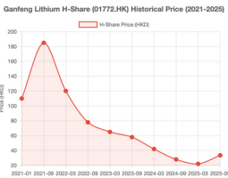
Ganfeng Lithium is positioned as a long-term beneficiary of global electrification. Yet, with lithium prices depressed, margins eroded, and leverage elevated, near-term fundamentals do not justify current valuations. Our DCF analysis indicates a fair value of HKD 25.5/share, and we therefore assign a SELL recommendation.

Figure3: GanFeng 5-year Stock Chart
Source: Company Fillings,Team Analysis
Business Description
Ganfeng Lithium Founded in Xinyu, Jiangxi Province in 2000, Ganfeng Lithium was listed on the Shenzhen Stock Exchange in 2010 and in 2018. It is a leading enterprise in China's lithium industry and also the first company in the industry to be simultaneously listed on both the A-share and H-share markets ("A+H" dual-listing). With the production of lithium compounds such as metallic lithium, butyllithium, lithium chloride and lithium carbonate as its foundation, the company focuses on the layout of the lithium industry chain and has established multiple production bases at home and abroad. It possesses complete battery manufacturing and recycling technologies, providing sustainable value-added solutions for battery manufacturers and electric vehicle producers. As such, it is an important participant and driver in the global lithium industry.

Key Market Coverage
Ganfeng Lithium has a market presence both domestically and internationally. Domestically: It has established production and resource projects in Jiangxi, Qinghai and Inner Mongolia, serving industries such as new energy vehicles and energy storage. Internationally: It has collaborated with major global enterprises including LG Chem, BMW, Tesla and Hyundai. Its products are exported to major global economies such as South Korea, Japan, Europe and the United States. It is an important participant and driver in the global lithium industry.
Business Model
Ganfeng Lithium has built a vertically integrated business model that runs through the upstream and downstream of the lithium industry. All links work in close coordination, with comprehensive efforts from the resource end to the application end, aiming to enhance overall competitiveness and profitability.

Ownership Structure
According to the data as of August 25, 2025, Hong Kong Securities Clearing (Agent) Company Limited, a Hong Kong-based enterprise, is the major shareholder with a shareholding ratio of 20%. Li Liangbin, the founder and actual controller of the company, holds a 18.77% stake individually. Wang Xiaoshen, the president of the company, has a shareholding ratio of 7.01%.

Figure 6:Timeline of Ganfeng Lithium development

Figure 4:Business model of Ganfeng Lithium
Source:Company Websites
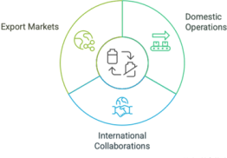

Figure 5: Ownership Structure of Ganfeng Lithium
Source: Team Analysis
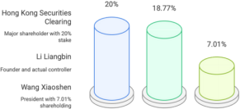

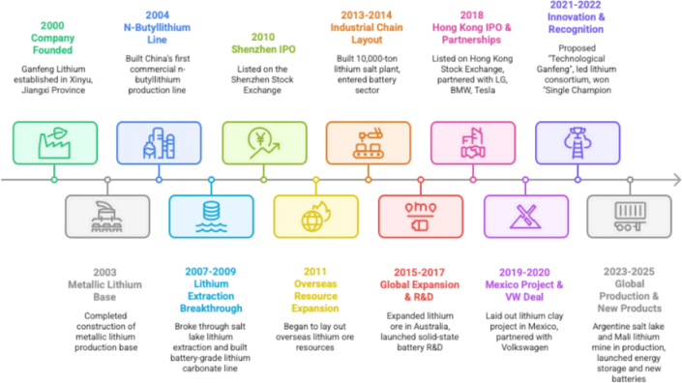

Industry overview

Complete ecological chain of the lithium industry,Cover the upper,middle and lower reaches and recycling cycle.Ganfeng Lithium is a cornerstone of the global new energy ecosystem. Its industry is defined by explosive growth driven by electrification, but also by volatility,
geopolitical complexity, and rapid technological change. Ganfeng's comprehensive strategy of securing a diversified upstream resource base, dominating midstream processing, and
innovating downstream in batteries and recycling, has cemented its status as a leading and resilient integrated lithium company poised to benefit from the long-term energy transition.
World’s leading lithium eco-enterprise--Positive
As the world's leading lithium eco-enterprise, Ganfeng Lithium's business segments cover from upstream 'lithium resource development', midstream' lithium refinery and lithium metal smelting', to downstream' lithium battery manufacturing and battery recycling'. Our products are widely used in EVs, energy storage systems, 3C products, chemicals and
pharmaceuticals, etc.
Ganfeng's lithium resources are located in several countries and regions worldwide, and we
have advanced technologies for 'lithium extraction from brine', 'lithium extraction from ore', and 'lithium recycling'. Our production capacity of lithium compounds and lithium metals is among the highest in the world. Ganfeng also has the capacity to manufacture and recycle batteries, providing EVs, battery, and electronics OEMs with raw material supply, battery customization, and recycling solutions.
Periodic sharp drop in lithium prices--Negative
Lithium is a highly cyclical industry, and the prices of its products (lithium carbonate, lithium
hydroxide) are greatly affected by supply and demand.According to the 2024 annual report of Ganfeng Lithium Industry, from 2021 to 2022, the surge in lithium demand has led to a sharp
increase in revenue. However, since 2023, due to the high prices in the early stage stimulating a large influx of capital, the production capacity of new mining projects has gradually been
released, and the supply-demand relationship has reversed, resulting in oversupply. The price of battery grade lithium carbonate has fallen back from its peak to around 100000 yuan/ton
(mid-2024 data).
Environmental-friendly industry,adopting circular economy--Positive
Ganfeng Lithium devotes to environmental-friendly industry,for instance, providing high-quality raw materials for global automobile,battery and material manufacturers and applying energy
storage equipment for solar,wind and other clean energy.Most significantly,they use
sophisticated process to recycle batteries.They provide Self-operated transportation
channels to ensure process safety,complete recycling network,which is more economical and safer,and Complete resource extraction types to improve recycling efficiency.
High production of lithium carbonate--Positive
In 2024, the total domestic production of lithium carbonate is about 660000 tons, an increase of 38% year-on-year. In terms of raw material types, spodumene accounts for half of the country, accounting for about 48%(pie chart A), an increase of 116% year-on-year. In terms of application scenarios, 67% of them are used for the production of lithium iron phosphate cathode materials; 12% is used for the production of ternary positive electrode materials.
Among the top 20 companies in China's lithium carbonate production in 2024, Ganfeng Lithium accounted for 5% of the total production, approximately 31200 tons, placing it at the forefront of the industry.(pie chart B)
Advanced technology as the foundation and innovation as the driving force--Positive
Ganfeng Lithium adopts 10 core technologies, namely: Efficient and clean lithium extraction
technology from lithium ore,Technology for comprehensive co-production of high-purity lithium salt from brine,Recycling technology of waste lithium materials,Lithium metal smelting and
purification technology,Deep processing technology of lithium-based anode materials,Solid- state lithium battery manufacturing technology,High electromagnetic shielding TWS battery technology,High-purity lithium oxide preparation technology,N-butyllithium synthesis
technology and High energy conversion efficiency and long life energy storage
technology.Additionally,they have 1043 scientific researchers: 4 national-level talents,
including 1 from National Talent Project, 2 from CAS Pioneer Hundred Talent Program, 3 from
National-level Innovative Talent Program; 8 provincial-level talents; 145 postgraduate and
postdoctoral researchers; 11 senior titles and 28 vice-senior titles.All above show its advanced technologies.

Competitve Positioning
Ganfeng Lithium is an integrator of the global lithium battery industry chain and a supplier of high value-added products.
Compared to upstream giants such as Tianqi Lithium(pie chart) or traditional chemical giants such as ALB and SQM, Ganfeng Lithium's core advantage lies in its ability to layout the entire industry chain and bind global top customers with high-end products , which gives it stronger risk resistance and long-term growth potential in the volatile industry.
[Below is a chart listing global competitors in lithium industry]

Figure 7 :Industry Sketch map

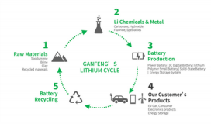
Source:Ganfeng’s official website

Figure 8:5-year revenue

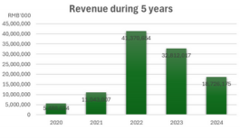
Source:Ganfeng’s 2024 annual report
Figure 9:Battery Recycling Flowchart
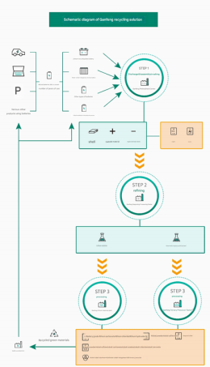

Source:Ganfeng’s official website

Pie chart A

Pie chart B
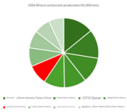

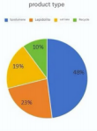
Source: website
Source:website

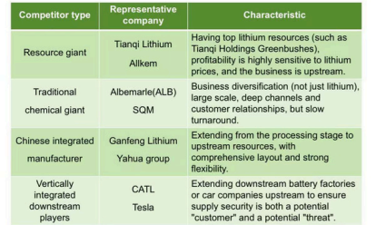

The Integrated Ecosystem Advantage
Source:team analysis
This is its fundamental strategic advantage, providing unparalleled risk resistance. Specific manifestation: Business coverage “Upstream lithium resource development → Midstream lithium compound deep processing → Downstream lithium battery manufacturing → Retired battery recycling”full life cycle.
So why is it an advantage?1.smooth cycle fluctuations: When lithium prices are high, upstream resource sectors are profitable; When lithium prices are low, the processing fees and
recycling business in the middle and lower reaches can provide stable cash flow, avoiding
drastic fluctuations in performance.2.maximizing profit retention: By keeping the profits of
upstream resources within the system and processing them into high value-added products
for resale, the maximization of value chain profits is achieved.3. ensuring supply chain security:
No matter how the industry changes, we can ensure the supply of our own lithium products without being threatened by external supply disruptions.
The Strategic Foresight&Financial Resilience Advantage
This is the management advantage that enables it to sustainably develop and stand out in the industry. It could be embodied in two aspects.First,forward looking
layout:they managed global layout of resources before the industry outbreak and take the lead in investing in the research and development of solid-state batteries, and seize the commanding heights of next-generation technology.Also,they are the earliest to build a large-scale recycling network, targeting future urban
mines.Second,financial stability:Compared to competitors (such as Tianqi, which was once in debt crisis due to mergers and acquisitions), Ganfeng's asset liability ratio is well controlled and its cash flow management is excellent .

Investment Summary
Based on the Company's "Upstream-Downstream Vertical Integration" Business Model Its core investment advantages can be further divided into five dimensions:
resources, production, technology, market, and operations. These dimensions
support each other to form a complete competitive barrier. When compared with other leading enterprises in the industry such as Tianqi Lithium., Ganfeng Lithium's unique advantages are even more prominent.

Thesis:#1 Global Multi-Category Layout, Dual Guarantees for Cost and Supply

A.)Diversified Resource Types to Avoid Single-Resource Risks
Ganfeng Lithium covers three major categories of lithium resources.SaltLake Lithium, lithium Clay, etc.During the lithium price downward cycle, different resource types enable the company to reduce overall costs by increasing lithium extraction capacity from salt lakes, meanwhile, spodumene mines have a short mining cycle, allowing quick responses to short-term demand growth. In comparison, although Tianqi Lithium has abundant spodumene resources (such as the Greenbushes mine in Australia, with a lithium concentrate capacity of approximately 1.34 million tons per year, equivalent to about 120,000 tons of LCE), its resource types are relatively single. This makes it slightly less flexible when responding to lithium price fluctuations and demand changes.

Figure 10: Ten technologies
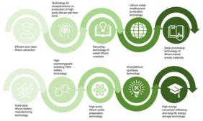
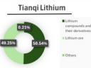
Source:Ganfeng’s official website
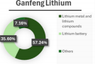
Source:team analysis

Figure 11: Industry Chain

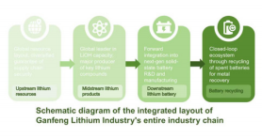
Source:Ganfeng’s official website

Figure 12 :Debt-to-Asset Retio

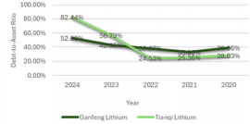
Source:Ganfeng’s 2024 annual report

Figure 13:Business model of Ganfeng Lithium
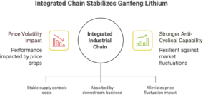

B.)Global Resource Distribution to Mitigate Geopolitical and Policy Risks
Ganfeng Lithium’s resource projects are evenly distributed both doestically (in
Qinghai, Jiangxi, and Inner Mongolia) and overseas (in Australia, Argentina, Mali,
and Mexico)Domestic projects: They are close to downstream battery and vehicle manufacturing clusters, reducing transportation costs. Overseas projects: Most
are located in regions with superior resources and relatively stable policies.
Through equity cooperation (e.g., taking a stake in Australia’s Pilbara Minerals) and long-term agreements to lock in resources, the company minimizes the impact of policy changes in a single country (such as adjustments to mineral taxes and
environmental protection restrictions) on resource supply. Tianqi Lithium’s
overseas resources are concentrated in Australia and Chile, which makes its resource regional diversification less comprehensive than Ganfeng Lithium’s. If policies in Australia or Chile change, the impact on Tianqi Lithium’s resource
supply may be more significant.
Thesis:#2 Sound Global Resource Layout and Solid Cost Advantage
The company covers multiple types of lithium resources at the resource end,
including spodumene (Australia), salt lake lithium (Argentina, Qinghai, China) and
lithium clay (Mexico), most of which are high-grade and low-cost projects. Financial data reflects the cost advantages and profit stability brought by the resource
layout. In 2024, the company's equity output of self-owned mines was
approximately 60,000 tons, with a self-supply ratio of 46%. In 2025, the equity output is expected to reach 100,000 tons, with a self-supply ratio of about 60%.
Take the Cauchari-Olaroz project in Argentina as an example: its long-term
operating cost is 6,543 US dollars per ton, showing an obvious cost advantage.
When lithium prices fluctuate, the relatively high self-sufficiency rate of resources enables the company to flexibly control production costs. In 2024, the tax-
included average price of lithium products was 104,000 yuan per ton, while the average operating cost was 83,000 yuan per ton. Such cost control ensures a certain profit margin and maintains profit stability.
Thesis:#3 Tied to Global Leading Customers, Ensuring Market Demand
The company's downstream customers include global new energy vehicle and
battery giants such as Tesla, BMW, LG Chem and Hyundai, and it locks in stable
orders through long-term cooperation agreements. Financial data reflects the
support of customer structure advantages for performance. In the first half of
2025, although the overall revenue declined due to factors such as lithium prices, stable customer cooperation guaranteed the business volume. Although the
revenue of lithium series products decreased due to falling lithium prices, sales
volume still maintained a certain level thanks to stable customer demand. At the same time, with the development of the domestic energy storage market, the
company's energy storage battery and system business is expected to become a new growth driver. The multi-field and global customer structure provides solid
support for the company's performance growth. in Argentina.

Investment Risks
I. Executive Summary
While Ganfeng Lithium has strong positions in lithium resources and a vertically integrated chain (mining → refining → battery), the current risk environment is nontrivial. Key threats are: weak pricing, heavy debt, regulatory & geopolitical risks.
II. Weak Pricing
There is evidence of oversupply in the lithium market: production expansions in China and Australia have increased supply while adoption of EVs has not risen fast enough to soak up all that capacity.
Government policies (subsidies, incentives) can shift, particularly for EVs and energy storage, which would reduce demand growth expectations.
As of mid-2025, battery-grade lithium carbonate prices have dropped substantially, in some cases below Ganfeng’s production cost, compressing or even reversing profits.
This has already triggered inventory write-downs and impairment losses. For example, in 2024, Ganfeng made inventory/asset impairment provisions ( ≈ RMB 0.42bn) and fair value losses ( ≈ RMB 1.48bn) due to falling prices and investments.
Risk: Weak demand or delayed EV adoption can lead to inventory build-up, pressure on
pricing, perhaps forced shutdowns or reduced utilization. If prices stay low or drop further, revenues may not cover costs; margins will remain squeezed; cash flows could turn
persistently negative.

Figure 14 :Ownership Structure of Ganfeng Lithium

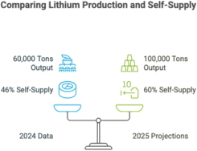

Figure15: Lithium production

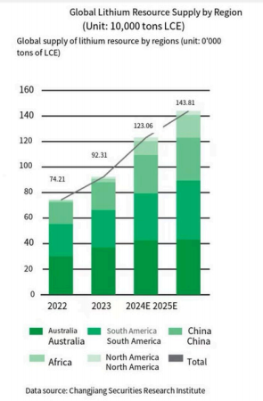

III. Heavy Debt
· Ganfeng’s debt levels have increased significantly: the debt–to–equity ratio is ~111.87%; total debt ~RMB 53.2B vs equity ~RMB 47.5B.

Figure 16: Lithium Price
Source:team analysis
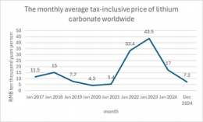
· Interest coverage and debt servicing may be difficult under conditions of falling revenue/margins.
Risk: Higher financing costs, risks of refinancing, cash flow stress, potential breach of debt covenants.
IV. Regulatory & Geopolitical Risks
· Lithium mining occurs in jurisdictions with political instability, environmental activism,
and changing legislation. Ganfeng has operations/projects in Argentina, Africa,
Australia. Delays in permitting, stricter environmental standards, community opposition, or even nationalization risk are real. The Mariana project in Salta, Argentina, for
instance, though supported by the current administration, still depends on political risk.
· Domestic regulation in China is tightening: crackdown on overcapacity;

Figure 17: Debt-to-Equity Ratio
Source:team analysis
licensing/license renewals; production halts if permits or licenses expire.
Risk: Delays, increased capex compliance costs, possibly reduced output.
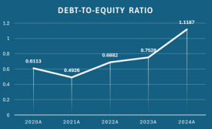
V. Conclusion
Ganfeng Lithium’s competitive strength lies in its extensive resource reserves and
vertically integrated value chain. However, the company’s risk profile is dominated by three factors:
· Weak Pricing: Persistent volatility and recent declines in lithium prices have materially compressed margins and triggered asset impairments, with profitability heavily
exposed to commodity cycles.
· Heavy Debt: Elevated leverage and recurring losses intensify refinancing pressure and constrain financial flexibility, creating a self–reinforcing fragility when negative external shocks occur.
· Regulatory & Geopolitical Risks: Operations in politically sensitive jurisdictions and tighter domestic regulatory oversight create uncertainty over project continuity,
compliance costs, and long–term resource access.
These risks collectively undermine earnings visibility and balance sheet resilience. Until
lithium prices stabilize and debt is prudently managed, Ganfeng remains highly sensitive to external shocks and policy shifts despite its strong industry positioning.

Financial Analysis

Figure 18: DuPont Analysis
source:Company reports,Team analysis
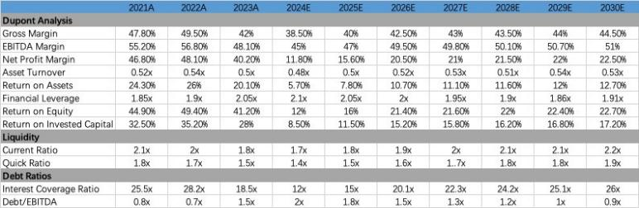
Margin periodic changes brought by lithium price

Figure 19:
Source:Team4 Analysis
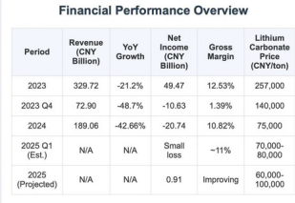
fluctuations
In 2022, the price of lithium carbonate soared to a record high of nearly 600,000
yuan/ton. Such a high product price has enabled Ganfeng LithiumIs gross profit margin to reach an astonishing 49.50%, and the net profit margin is as high as 48.92%. The
companyIs net profit attributable to the parent company exceeded 20 billion yuan,
reaching a historical peak. However, with the continuous release of industry production capacity and the slowdown in downstream demand growth, the lithium supply and
demand pattern has reversed. In 2024, the price of lithium carbonate fell to about
75,000 yuan/ton, down more than 80% from the high point in 2022. The gross profit
margin for the whole year of 2024 plummeted to 10.82%, and the company suffered its first annual loss since listing, with a net profit loss attributable to the parent company
of 2.074 billion yuan. Entering 2025, the price of lithium carbonate will fluctuate at a low level [$7–80,000 yuan/ton range]. Although the industry as a whole is still difficult,
Ganfeng LithiumIs gross profit margin has begun to show initial signs of stabilization and repairability。

Severe debt problems in short term with EBITDA analysis
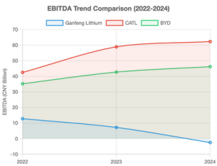
Ganfeng Lithium's total liabilities reached 53.244 billion yuan at the end of 2024, a year-on-year increase of 35.20%. What is more noteworthy is its short-term debt repayment pressure: at the end of 2024, the monetary
funds will be 5.944 billion yuan, but the short-term borrowings will be as high as 9.069 billion yuan, which means that there is a certain short-term funding gap.
In terms of EBITDA, there was even a negative annualized EBITDA (-105,622.4 million yuan) in the first quarter of 2024, which directly led to the deterioration of the
debt/EBITDA ratio to -25.26 in the current period. Although gross profit margin in the first quarter of 2025 rebounded year-on-year and quarter-on-quarter (to 12.95%),
showing initial signs of stabilization, overall profitability is still at a low level.

Dividend distribution policy
The fluctuations in the lithium industry itself and the company's profitability also
make dividend distributions cyclical. During the high boom period of the industry, the company paid more generous dividends; During the downward adjustment period,
the amount of dividends also decreased. According to the "2025-27 Shareholder
Return Plan", Ganfeng Lithium promises that the annual cash dividend ratio will not be less than 10% of the distributable profit of the year, and the cumulative cash dividend in the past three years will not be less than 30% of the average annual distributable profit. If there are specific situations such as distributable profit per share of less
than 0.1 yuan or asset-liability ratio of more than 70%, the company can adjust the dividend ratio. This provides the company with the flexibility to retain the necessary cash flow to cope with operating needs and debt pressures during difficult times.
Use its own stability to achieve cyclical transitions Vertically integrated industrial chain: The company's business
covers upstream lithium resource development, midstream lithium
salt deep processing and lithium metal smelting, downstream lithium battery manufacturing and recycling, forming a vertically integrated industrial chain.
Global high-quality lithium resource reserves: Abundant lithium resource reserves (more than 60 million tons of LCE) and

Figure 20: EBITDA Trend
Source:Company Fillings

Figure 21:Dividend per share
Source:Team Analysis
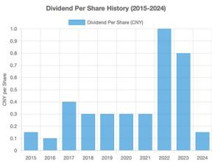

continuously improving self-sufficiency rate (expected to exceed 50% in 2025) are the foundation of the company's policy of reducing costs and increasing efficiency and the source of cost competitiveness.

Figure 22: Ganfeng lithium cycle
Source:Company filling
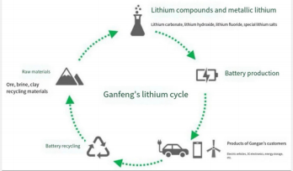

Valuation
We conducted an intrinsic valuation cross-checked by relative benchmarks to arrive at a 12- month target price of HK$25.52 per share for Ganfeng Lithium, implying –32.5% downside
from the HK$37.78 close on September 5, 2025. Our framework relies primarily on a 5-year FCFF DCF with a Gordon terminal, triangulated against an exit-multiple view and peer trading ranges. Given Ganfeng’s commodity exposure and investment cycle, we place greater
weight on DCF and use the others to validate reasonableness rather than to re-anchor the target; all cross-checks bracket the DCF and round the blended outcome to HK$25.52.
DCF with 5-year projection period
We value Ganfeng using a 5-year FCFF DCF (2025E–2029E) with the mid-year convention. The model is built in RMB and translated to HKD for per-share outputs. (Since company’s
annual report using RMB)Because revenue is highly sensitive to lithium pricing, we forecast top-line as price × volume, where price follows our neutral mid-cycle deck for China battery- grade Li2CO3 and volume reflects planned project ramps and mix normalization.Key cash-
flow profile (RMB bn):2025E –6.32, 2026E –2.47, 2027E –0.38, 2028E +0.67, 2029E +1.22.
The negative early-period FCFFs reflect front-loaded capex in the reinvestment phase; inflection occurs as ramps stabilize and working capital normalizes.

Revenue growth
Ganfeng’s sales track EV/ESS demand and China lithium prices. We model 2024A revenue of 18.73bn, rising to 19.66bn (+5%) in 2025E and 23.22bn (+18%) in 2026E, with further
growth thereafter driven by incremental volumes and a normalization in realized prices.
Profitability recovers alongside the cycle: EBIT margin moves from –6% (2024A) to 4%
(2025E), 8% (2026E), 12% (2027E), 13% (2028E) and 14% (2029E), consistent with operating leverage, learning-curve benefits and mix.
Management’s strategy & margin trajectory
Management is exiting the heaviest phase of the capex cycle and pivoting to cost discipline and yield optimization. With ~front-loaded capex (2025E–2027E) and moderating additions thereafter (maintenance + debottlenecking), margins become increasingly volume- and
cost-curve-driven rather than investment-driven. We therefore underwrite a measured margin expansion over the projection period rather than a quick reversion to peak
conditions.

WACC
· Cost of Debt (after-tax): 4.05%, derived via a credit-spread approach on existing borrowings.
· Cost of Equity: 5.56% from CAPM using Rf = 1.77%, β = 0.72, and ERP = 5.27%.
· Capital mix: Based on recent averages, yielding WACC = 5.15% (mid-year discounting applied). This sits in a conservative range for a cyclical materials name with improving balance-sheet flexibility.

Terminal growth and exit multiple
We assume a conservative low single-digit terminal growth consistent with long-run inflation plus real activity. As a cross-check, we apply an 8.0× exit multiple to terminal-year EBITDA. The two approaches yield:
· Perpetuity TV: ~RMB 110.8bn (undiscounted)
· Exit-multiple TV: ~RMB 50.7bn (undiscounted)
· Average TV used in base case: ~RMB 80.8bn (undiscounted)
PV of TV (mid-year): ~RMB 64.4bn

From enterprise value to equity value
· Enterprise Value: ~RMB 57.2bn (PV of 2025E–2029E FCFF plus PV of TV)
· Balance-sheet bridge: cash, marketable securities, and interest-bearing debt as per the model; other equity claims treated per accounting mapping
· Equity Value: ~RMB 46.9bn
· Diluted shares outstanding: ~2.005bn
· Fair value: RMB 23.42 per share = HK$25.52 per share

Why our target sits below spot
At the reference price (HK$37.78), the market is implicitly underwriting a higher long-term price deck and/or a lower effective discount rate than our base case. Given the sensitivity of FCFF to price and the convexity of TV to WACC, both need to move favorably to support the spot quote. Our cross-checks (exit multiple and peer ranges) validate but do not
override the DCF.

Sensitive test
The sensitivity analysis further reveals that valuation is highly dependent on discount rate and terminal growth assumptions:
A ±50bps change in WACC drives the implied value between RMB 12.5–19.0.
A ±50bps change in g widens the range between RMB 12.7–20.5.
Therefore, we conclude that the current market price of Ganfeng Lithium embeds overly
aggressive growth and cost of capital assumptions. On a DCF basis, our analysis supports a SELL recommendation, with a fair value range of HKD 19–29 and a base-case target price of HKD 25.5.

Figure 23: Revenue and Lithium price relationship
Source: Team Analysis,UBS & Fastmarkets
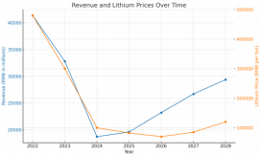

Figure 24: FCFF (Free Cash Flow

to the Firm) and Projected Revenue from 2025E to 2029E

Source: Team Analysis(DCF model)
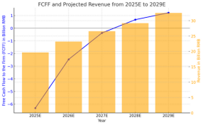

Figure 25: EBITDA Forecast and Adjusted EBITDA Margin chart from 2025E to 2029E
Source: Team Analysis (DCF model)

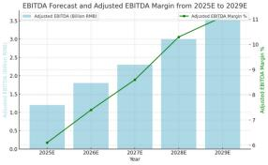

Figure 26: Sensitive test with WACC and Growth rate
Source: Team Analysis,NBS
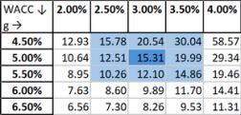

ENVIRONMENTAL, SOCIAL & GOVERNANCE

Figure 27: ESG Scorecard
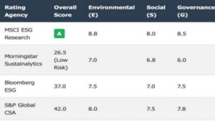
Source: CompanyWebsites
As the importance of sustainability continues to grow, Ganfeng Lithium's ESG metrics influence stakeholders' perceptions of the business. Overall, Ganfeng Lithium has been recognized by a number of ESG rating agencies, but it still needs to pay attention to the issues behind its corporate governance and risk management links.
ENVIRONMENTAL
Carbon Emissions and Energy Management:
The company reduces carbon emission intensity through technological transformation and energy substitution. In 2024, its carbon emissions per ton of products will be reduced by 3.26%, and coal consumption will be reduced by 29.51%. From a 2019 baseline, waste

Figure 28：Comparative ESG scores
Source: Team Analysis
emissions per ton of product have been reduced by 66.2%. The company has introduced steam recompression technology in many factories, and automation technology and
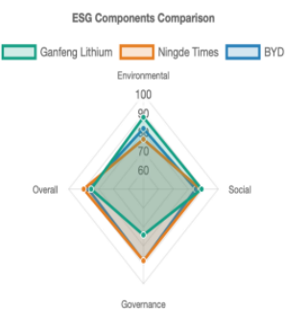
equipment have improved unit energy efficiency.
The company is also building solar photovoltaic power plants around the project (such as near the salt lake project in Argentina) to use cleaner energy for lithium extraction to reduce dependence on traditional fossil energy.
Water Resource Management:
The company optimizes water resource management in salt lake mining and
lithium extraction, introduces recycling and wastewater treatment technologies, reduces dependence on local water resources, and reduces environmental
impact.
Biodiversity Conservation:
Around the Argentine Salt Lake Project, the company has established ecological reserves and buffer zones, and implemented a biodiversity conservation program to protect wildlife habitats, including flamingos.
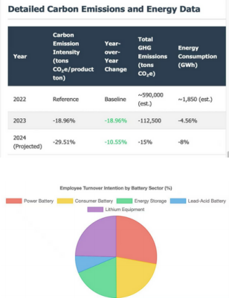
SOCIAL

Figure 29:

Figure 30:

Community Impact:
In Argentina, the company promotes food self-sufficiency for about 10 local families (60 people) through the "Paraje Torzalito Community Vegetable Garden Project". The
company has built a localized lithium salt production base near the lithium salt lake in Argentina, providing more employment opportunities for local residents
Supply chain responsibility:
The company's wholly-owned subsidiary, Ningdu Ganfeng, has passed RMI's RMAP
verification. The company has established a responsible supply chain due diligence
management team, actively follows domestic and foreign standards, and is committed to achieving supply chain transparency and responsible procurement.
Employee treatment:
Ganfeng Lithium provides employees with statutory "five insurances and one housing fund" and a variety of subsidies, and has a rich holiday welfare and care program.
Ganfeng Lithium's score on OHS key indicators has been significantly improved, and the company has maintained a sound safety management system to ensure the safety of
employees.
GOVERNANCE
Leadership Structure:
The company has established a board-level sustainability committee that leads climate goal setting, strategic planning and oversight of implementation, and reports annually to the board. The committee will have 100% attendance at its meetings in 2024.
Shareholder composition:
Li Liangbin's family holds 19.97% of the company's equity and is the actual controller of the company. At the same time, foreign investors and domestic institutional investors are
widely involved (e.g. HKSCC NOMINEES LIMITED, Wang Xiaoshen...)
Executive compensation:
The company's senior management salary distribution plan must be reported to the board of directors for approval, reflecting governance checks and balances. The committee is also responsible for formulating or changing equity incentive plans and employee stock ownership plans, which shows that Ganfeng Lithium binds the interests of executives to the long-term development of the company through long-term incentives.
ESG Risks and Disputes
The company was fined about 4.42 million yuan for allegedly using insider information to trade Jiangte Motor shares. The incident exposed the company's internal control and
compliance management deficiencies, and the executives' lack of compliance awareness. In 2024, the company's PLS stock price fell sharply due to the collapse in lithium prices,
resulting in a fair value change loss of 1.64 billion yuan. Commodity futures options
hedging and foreign exchange hedging are also not effective. This reflects the company's inadequacies in financial risk management.

Appendix: Data Sources and Notes
Data Sources:
All data and information related to Ganfeng Lithium Group Co., Ltd. (hereinafter referred to as "Ganfeng Lithium") in this document are collected from open and authoritative channels to ensure authenticity and reliability. The specific data sources are as follows:

1. Official Financial Reports of Ganfeng Lithium
Including the company’s annual reports (2018–2024), semi-annual reports (2025 H1), and quarterly financial disclosures, which are publicly released on the Shenzhen Stock Exchange (Stock Code: 002460) and Hong Kong Stock Exchange (Stock Code: 01772). Core data such as balance sheets, profit and loss statements, and cash flow statements are directly extracted or summarized from these official reports.

2. Publicly Disclosed Announcements
Major business cooperation announcements (e.g., long-term supply contracts with LG Energy Solution, Volkswagen Group), upstream resource project updates (e.g., commissioning of the Mariana Salt Lake Project in Argentina), and strategic investment announcements released by Ganfeng Lithium on stock exchange disclosure platforms.

3. Industry Research Reports and Statistical Databases
Supplementary data on the global lithium industry, such as lithium resource reserves, industry average resource self- sufficiency rates, and market demand trends, are referenced from reports by authoritative industry institutions (e.g., S&P Global, Benchmark Mineral Intelligence) and national statistical databases.

4. Official Websites of Partner Enterprises
Basic information about cooperative enterprises (e.g., business scope of PetroChina, CATL) and public information about cooperative projects are sourced from the official websites of the respective enterprises to confirm the authenticity of cooperative relationships.
Notes:
• Some data for 2025 H1 (e.g., non-current liabilities in the balance sheet, partial investing cash flow data) is pending the release of Ganfeng Lithium’s full semi-annual report; the current data is based on preliminary disclosures and will be updated in line with the official final report.
• Minor differences in data may exist due to variations in statistical calibers (e.g., rounding of decimal places) between different reports, and the official financial reports of Ganfeng Lithium shall prevail in case of discrepancies.
• The logos and basic introductions of related enterprises are sourced from their official brand identity systems and public brand promotion materials, used only for illustrative purposes in this document.

Appendix: Data Sources and Notes
Appendix 1 : Competitor profile
Appendix 2 : Breakdown of business segment
Appendix 3 : Financial highlights for the past 5 financial years
Appendix 4 : Background
Appendix 5 : Key Financial Data Comparison (2024 - H1 2025)
Appendix 6 : Cash flow statement(2020-H1 2025)
Appendix 7 : Profit and loss statement(2020-H1 2025)
Appendix 8 : Balance sheet(2018-2025)

Appendix 1 : Competitor profile
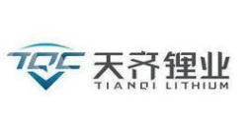  • Holds significant stakes in high - quality | 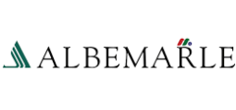  • As a global leader in the lithium industry, it has a wide range of business layout  worldwide, including lithium mines,  processing plants, and R & D centers.  • Leads in lithium battery materials  technology, providing high - performance  products for new energy vehicle and energy storage industries.  • Maintains long - term and stable  cooperative relationships with major global battery manufacturers, ensuring a stable  sales volume.  • Faces intense competition from emerging lithium companies, especially in the field of new lithium extraction technologies.  • Continuously increases investment in  research and development to develop new lithium products and application  technologies, and expand market share. |  | 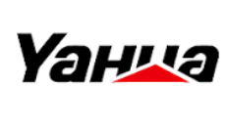  • Operations：Yahua Industrial Group has  built a complete lithium industry chain，  involved in lithium ore mining, lithium  compound production, and has also  extended to some downstream applications related to lithium - ion batteries.  • Market Performance：In the domestic  market, it has a wide customer base,  including many well - known battery and new energy vehicle manufacturers. In the  international market, it is gradually increasing its presence.  • Development Constraints：The company may face difficulties in competing with  international giants in terms of global  resource allocation. In addition, with the continuous upgrading of environmental protection requirements in the lithium  industry.
lithium mines, such as the Greenbushes
lithium mine in Australia, which provides a solid foundation for its raw material supply.
• Focuses on the production and sales of lithium compounds, with a large - scale and advanced production base.
• Has a relatively concentrated customer
base in the domestic market, and is actively exploring overseas markets to diversify its customer structure.
• Is affected by the cyclical changes of the lithium market; when the market is in a
downturn, profit margins may be compressed.
• Strengthens cooperation with upstream
and downstream enterprises in the industrial chain to achieve integrated development
and enhance overall competitiveness.
Appendix 2 : Breakdown of business segment
Segment breakdown and revenue generation |  | Key customers

(1). Segment Breakdown (By Business Line)
The company’s business is vertically integrated across the lithium industry chain, mainly divided into four core segments, each with distinct positioning and contribution.
• Lithium Compounds
◦ Core Products: Lithium carbonate, lithium hydroxide (battery-grade & industrial-grade), lithium chloride, etc.
◦ Application Scenarios: Dominantly used in lithium-ion batteries for new energy vehicles (NEVs), consumer electronics (e.g., smartphones, laptops), and energy storage systems (ESS). Industrial-grade products also serve ceramics, glass, and metallurgy.
◦ Role: Historically the largest revenue contributor, forming the "basic" of Ganfeng’s income due to stable demand from battery manufacturers.
• Lithium Metals & Alloys
◦ Core Products: High-purity lithium metal (99.9%+), lithium alloys (e.g., lithium-aluminum, lithium-magnesium alloys).
◦ Application Scenarios: Key materials for solid-state batteries (emerging demand), aerospace materials, and pharmaceutical intermediates.
◦ Role: A high-value-added segment with growth potential, aligning with the industry’s shift toward next-gen batteries. It currently accounts for a smaller but fast-growing share of
revenue.
• Lithium Batteries
◦ Core Products: Consumer batteries (e.g., lithium primary batteries for small devices), power batteries (for NEVs, especially in the two-wheeler and low-speed EV markets), and energy storage battery packs.
◦ Application Scenarios: Downstream direct-to-customer (D2C) and B2B cooperation with small-to-medium EV makers and consumer electronics brands.
◦ Role: A strategic segment to extend the industrial chain downward, reducing reliance on midstream compound sales. Revenue share is expanding as Ganfeng strengthens battery R&D and production capacity.
• Lithium Resources & Others
◦ Core Business: Overseas lithium resource development (e.g., mines in Australia, salt lakes in Argentina), lithium ore trading, and technical services (e.g., lithium extraction technology licensing).
◦ Role: Not a direct revenue driver in the short term, but critical for raw material self-
sufficiency (reducing dependence on external ore suppliers). It supports the profitability of upstream and midstream segments by controlling resource costs.

As a global leader in the lithium industry, Ganfeng’s key customers focus on high-demand sectors,
forming stable partnerships that support its core business. Here’s a detailed yet concise breakdown:

1. EV Manufacturers
Ganfeng partners with global and domestic EV
giants. Internationally, it supplies battery-grade LiOH to Tesla’s battery suppliers, has a 10-year lithium
chemical supply deal with Volkswagen Group (plus JVs in battery recycling and solid-state batteries), and a 2024–2027 LiOH contract for Hyundai; it also collaborates with BMW. Domestically, it has full-
value chain cooperation with Changan Auto and combines raw material supply with strategic
investment for GAC Aion.

2. Battery Producers
This is a critical segment for Ganfeng. It has a 2019– 2025 contract with LG Energy Solution, covering
92,600 tons of LiOH and Li2CO3. It also maintains
stable ties with CATL (the world’s top battery maker), with cooperation rooted in consistent product
quality and sufficient capacity (specifics undisclosed).

3. Consumer Electronics & Energy/ESS
In consumer electronics, it serves Apple, Samsung, and Huawei—providing specialized lithium materials for their device batteries (details kept confidential). In energy storage, it secured a 1.2GWh liquid-cooled ESS order from PetroChina via a June 2025 bid,
expanding into integrated ESS solutions.

(2). Revenue Generation Model
Ganfeng’s revenue comes from the above segments, with its integrated chain and global resource layout forming two core advantages for stable income:
• Midstream-Driven, Upstream-Supported
◦ Main Revenue Source: Sales of lithium compounds (lithium carbonate/hydroxide) to battery giants (e.g., CATL, LG Energy Solution) and downstream EV makers. This segment relies on economies of scale and stable long-term supply contracts (offtake agreements) to ensure
steady cash flow.
◦ Cost Advantage: Self-owned lithium resources (mines/salt lakes) cover ~50% of raw
material needs (data based on industry estimates), lowering exposure to volatile lithium ore prices and improving gross margins compared to non-resource-backed peers.
• High-Value Segments for Growth
◦ Lithium Metals: As solid-state battery technology advances, demand for high-purity lithium metal is rising. Ganfeng, a global top-3 lithium metal producer, is capturing premium pricing in this niche market, driving revenue growth.
◦ Lithium Batteries: By entering downstream battery manufacturing, the company bypasses midstream competitors and builds direct relationships with EV/ESS clients, creating a
"compound + battery" dual revenue stream.
• Global Market Diversification
◦ Geographic Mix: Revenue is split between China (domestic NEV/ESS demand) and overseas markets (Europe, North America, Asia-Pacific). Overseas sales (especially to EV markets like
Europe) are growing faster, reducing reliance on China’s cyclical policy and market fluctuations.
-Key Takeaway
Ganfeng’s revenue structure is characterized by"midstream as the foundation, upstream
ensuring stability, and downstream/high-value segments driving growth". Its integrated chain not only hedges industry cyclical risks but also positions it to benefit from both current lithium- ion battery demand and future solid-state battery trends.

4. Others
It supplies high-purity lithium to military enterprises (for equipment and satellite batteries) and caters to
ceramics (boosts strength), glass (lowers melting
temp), and pharmaceuticals (for mental health meds)— diversifying its customer base.
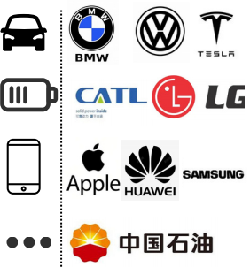

Appendix 3 : Financial highlights for the past 5 financial years
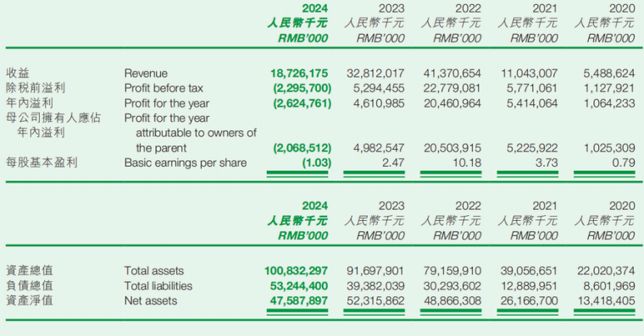
Source:Ganfeng’s 2024 annual report

Appendix 4 : Background
General profile:
Founded in 2000 and headquartered in Xinyu, Jiangxi Province, China, Ganfeng Lithium Group is a global leader in the lithium industry, operating across the entire lithium value chain—from resource extraction to battery manufacturing and recycling. As the first lithium company listed on both the
Shenzhen Stock Exchange (002460) and Hong Kong Stock Exchange (01772), it boasts robust financial resources and international influence.

1. Upstream Lithium Resources:
With strategic investments in lithium mines and salt lakes worldwide, including projects in Australia (Mount Marion), Argentina (Cauchari-Olaroz,

Mariana), and Mali (Goulamina),the company controls over 84 million tons of lithium carbonate equivalent (LCE) resources . Its resource self-sufficiency rate is projected to exceed 50% by 2025, significantly higher than the industry average .

2. Midstream Lithium Chemicals:
As the world’s largest lithium metal producer and China’s top lithium compound manufacturer, Ganfeng produces over 40 lithium-based products,
including battery-grade lithium hydroxide and carbonate. Its lithium chemical production capacity reached 277,000 tons in 2025, with a focus on high- purity materials for EV batteries .

3. Downstream Battery Manufacturing:
The company’s lithium battery business covers power batteries, energy storage systems (ESS), and solid-state batteries. In 2025, its ESS division
secured a 1.2GWh liquid-cooled ESS order from PetroChina, marking its entry into large-scale energy storage solutions . Its solid-state battery R&D has achieved breakthroughs, with energy densities up to 360Wh/kg and plans to commercialize 5GWh capacity by 2025 .

4. Battery Recycling:
Ganfeng operates advanced recycling facilities with an annual capacity to process 34,000 tons of spent lithium-ion batteries, recovering lithium, cobalt, and nickel for reuse .
Global Strategic Layout
• Resource Security:
Ganfeng’s diversified resource portfolio includes lithium spodumene, brine, and mica. The Mariana Salt Lake Project in Argentina, commissioned in February 2025, uses green extraction technologies to produce lithium at 35-40% lower costs than traditional methods, boosting its global
competitiveness .
• Technology Leadership:
As a pioneer in solid-state batteries, Ganfeng holds the second-highest number of global patents in this field. Its oxide and sulfide solid electrolytes enable longer battery life and enhanced safety, with partnerships involving international automakers for next-gen EV applications .
• Sustainability:
The company has joined the UN Global Compact and emphasizes green production, with solar-powered mining operations and water-efficient brine processing in Argentina .
Financial & Market Performance
Despite challenges in the lithium market in 2025, Ganfeng achieved a year-on-year reduction in losses during H1 2025, with lithium battery revenue growing 9.89% to ¥2.975 billion. Its vertical integration strategy helped maintain a 8.36% gross margin in lithium chemicals amid price declines . The company’s market capitalization fluctuated around ¥80-100 billion in 2025, reflecting investor confidence in its long-term growth potential .
Key Partnerships & Milestones
• EV & Battery Clients:
Ganfeng supplies lithium materials to global giants like Tesla, Volkswagen, LG Energy Solution, and CATL, with long-term contracts (e.g., 92,600 tons of LiOH/Li2CO3 to LG from 2019-2025) .
• Strategic Alliances:
In 2025, it partnered with Lithium Argentina AG to develop the PPGS Salt Lake Project, targeting 150,000 tons/year LCE capacity by 2030 .
• Innovation Awards:
Recognized as a National High-Tech Enterprise, Ganfeng’s R&D centers have won multiple accolades for breakthroughs in direct lithium extraction and battery recycling technologies .
Vision & Future Outlook
Ganfeng aims to leverage its full-value chain ecosystem to drive the transition to clean energy. With plans to expand lithium production to 500,000 tons LCE by 2030 and solid-state battery capacity to 20GWh, the company is positioned to capitalize on surging demand for EVs and energy storage globally

. Global Upstream Lithium Resource Distribution
Source:team analysis
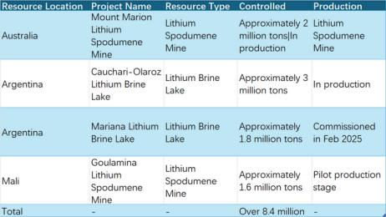

Revenue Share
Source:team analysis
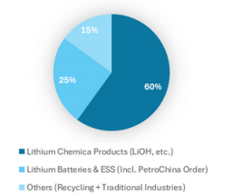

Total Lithium Chemical Capacity Line Chart
Source:team analysis
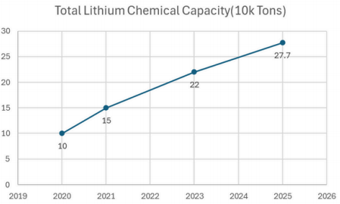
Ganfeng Lithium's Key Targets (2025-2030)
Source:team analysis
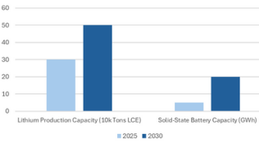

Appendix 5 : Key Financial Data Comparison (2024 - H1 2025)
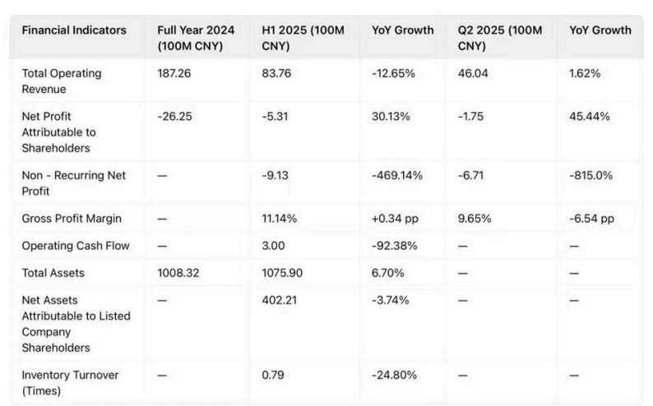
Source:Ganfeng’s 2024 annual report

Appendix 6 : Cash flow statement(2020-H1 2025)
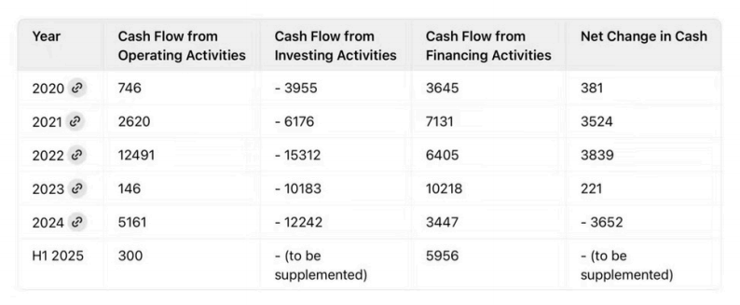
Source:Ganfeng’s 2024 annual report
Appendix 7 : Profit and loss statement(2020-H1 2025)
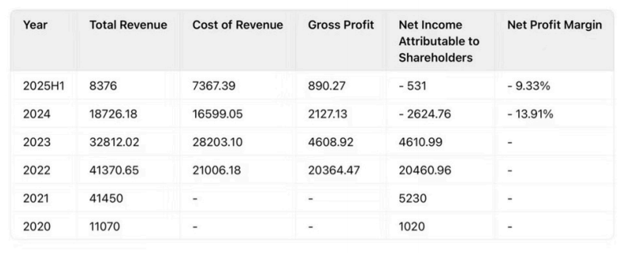  Appendix 8 : Balance sheet(2018-2025) | Source:Ganfeng’s 2024 annual report
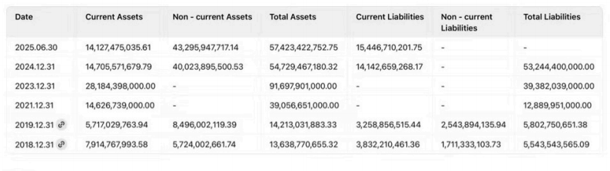

Source:Ganfeng’s 2024 annual report

